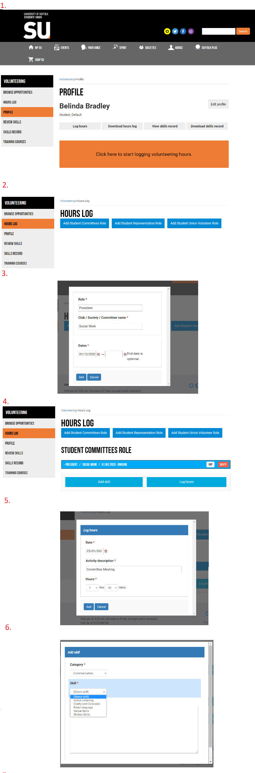
- Firstly, click on the tab ‘Suffolk Plus’. You’ll be prompted to make a profile which just means filling in a few details so we know who to reward. Once you’re all set, click on ‘profile’ and this is what you’ll be presented with.
- Click on ‘log hours’. You’ll have to create the role you hold currently to begin with, but once this is made you’ll have it set up for the rest of the award. A student committee role is any role within Student Activities, and will probably be a committee or student led group volunteer. A student representation role is for Officers and Course Reps. A Student Union role is anything that doesn’t fall into the other categories and is benefiting the whole students’ union.
- Create a role for every post you have as shown in the picture on the left. If you haven’t finished the role, leave the end date blank.
- Once you’ve created the role, you can click on it to be given the option to add skills or log hours.
- Logging hours is simple as shown in picture number 5. Just write a brief description of what you were doing such as ‘committee meeting’ or ‘hosting an event’. Try to remember the date and time as accurately as possible – it will be useful to do this as you go in following years.
- You’ll be given the option to start recording skills as you go too. Then at the end of the year, you’ll have a skills record that you can download for future use, e.g. when writing a CV or to bring to an interview. There are lots of different categories and skills listed, just choose the one that you’ve demonstrated and write a short sentence on how!
Each time you log an hour, this will contribute to your award. You can log hours throughout your entire time at university, starting from the 20-21 academic year and until you graduate, giving you even longer to work towards gold!

To submit, go to this website: https://www.uosunion.org/suffolkplusaward/

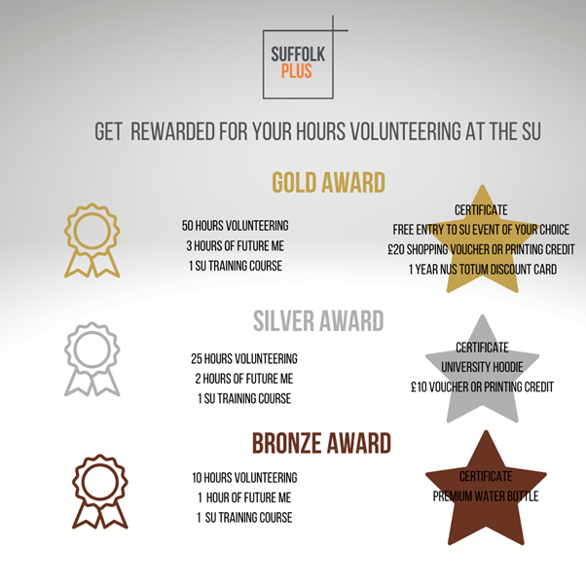

So how many hours should you back track? We’ve estimated exactly how many hours the average committee member would dedicate:

2x Training (General). Date to log: Either September 16th (existing societies) or 13th November/December 11th (New societies) and 18th February
1x Social Media and Safeguarding. Date to log: 4th February
1x Chair training (Chairs of AC only) Date to log: 18th February
1x Specialised training (Treasurer, key signatory role training, personal training). Date to log: 26th February
10x Committee Meetings (Around once a month, if your society met more regularly then include more. To log dates, just choose a regular week day every month from when you started).
5x Small Session hosting (An average of small socials or sessions but on by the society or sport the engage members. To log dates, look back on socials and event calendars!)
5x Sport set ups (An average based off committee members taking turns to set up sporting sessions and complete admin tasks. To log dates, look back on socials and event calendars!)
3x Event Plan (That’s one big event every term with an hour of planning for it. Choose the month before the event date to log the hour).
3x Event hosting (as above but log the date you actually ran the event).
3x Event set up and down (same as above).
6x Event admin (running ticket sales, organising zoom or room bookings, sending emails and invites, making posters. Log two weeks before event date)
4x President’s managerial work (just for the President to log for extra work recruiting, running and overseeing the society/sport. Log one day for ease at either the start or end of the year).
3x Treasurer’s financial work (just for the treasurer to log for submitting finances, managing reports and sending requests. Log one day for ease at either the start or end of the year).
3x Secretary’s administrational work (to log for completing administrative tasks and maintaining smooth running of society. Log one day for ease at either the start or end of the year).
2x Social Secretary/ Wellbeing Officer (Additional hours recorded for assistance with the society. Log one day for ease at either the start or end of the year).
3x Activities Committees (we check attendance so please only record if you represented the organisation during the event). Dates to log: 3rd February, 24th March, 26th May.
1x Assisting with elections (if you helped with the advertisement, sent emails or if your role has been filled for the next year, you can log this hour. Date to log (results day 1: 10th May or 1st July)
2x Planning and Hosting an AGM (Your society/sport will do this in July, so you’ll have two hours to submit for the date you hold it then)
2x Planning for freshers fair (Freshers fair date: 22nd September, Refreshers date: 23rd February).
Any hours spent being a volunteer when we’ve asked for submissions for social media, quotes, time spent doing surveys, if you’ve sent in feedback, if you’ve attended something on behalf of the activities department. We’ve had a few open days and presentations, were you a part of this? Did you spend time writing a nomination for a competition or perhaps you spend a while recruiting? Were you a regular social media poster for the group? Or perhaps you arranged merchandise to be brought and collected. Have you been a part of Green Suffolk? All this counts!

What skills can be submitted?

You’ll be asked to review some skills you’ve demonstrated throughout the year. You get a choice of the following (listed below). Using the sentences provided as a reference if needed, just write a quick sentence about how and where you’ve applied these skills.

Communication skills
Active Listening - Taking in what is being said and understanding it. Able to use that information and assist or apply it later on.
Body Language - The movements and postures by which attitudes and feelings are communicated.
Clarity and Concision - Presenting information in a clear and precise way, communicating effectively.
Verbal Skills - The use of speech and spoken words to share information with other people effectively. Being able to project accurately and professionally.
Written Skills - Articulation on paper or digitally. A way of communication effectively using literacy skills.

Positive Attributes

Adaptability - Being able to adjust to the environment, conditions or changes.
Creativity - Someone who uses imagination or original ideas to create something; inventiveness.
Proactive/ Enthusastic - Making things happen and is eager to assist their development.
Professionalism/ Punctuality - Someone who is able to maintain quality and meet expectations. They're consistently well mannered, hardworking and doing things correctly.
Reliability/ Accountability - Being trustworthy. Having a reliable reputation. Showcasing a consistent effort to do things to your full ability. People are able to rely on you.

IT skills

Administration - The process of running technological applications well, such as ticketing or registrations.
Design - Being able to plan and construct, and create online resources.
Editing - Correcting, condensing, or modifying information.
Good Understanding of Technology - Being able to optimise online platforms by understanding how it works, functions and recognising what would be beneficial.
Website Application - Being responsible for all aspects of keeping the website/ online platforms, content and design fresh, backed up, and fully functional.

Team Work skills

Collaboration/ Networking -The action or process of interacting with others to exchange information and develop professional or social contacts.
Commitment - Being dedicated to your cause.
Conflict Resolution - Finding a way for two or more parties to find a peaceful solution to a disagreement among them, or problem solve an issue.
Empathy - The capacity to understand or feel what another person is experiencing from within their frame of reference, that is, the capacity to place oneself in another's position. This may help you to work with or assist someone in the same project.
Engagement - Achieving involvement from those involved and working together.

Leadership skills
Confidence - Trust in your own ability. Able to project your ideas loudly, clearly and with complete belief in yourself.
Motivation - Being goal-oriented and driven consistently, or encouraging others to achieve.
Resilience - The capacity to recover quickly from difficulties, or problems. This means being able to overcome hardships to assist others to the progression of your project.
Team Management/Delegation - The ability to administer and coordinate a group of individuals to perform a task and hand out tasks.
Time Management/ Prioritisation - The ability to use one's time effectively or productively. Also having the skill of judging and completing tasks in order of importance.

Enterprise skills
Commercial/ Trend Awareness - The ability to understand what would make your project successful through research, keeping up to date with similar projects and making decisions based on this.
Decision Making - Being able to make choices by identifying a decision, gathering information, and assessing alternative resolutions.
Innovation - Creating new ideas or solutions in a new way. Thinking outside of the box.
Promotion/Persuasion - Being able to publicise and promote your project to other. Alongside this, you're able to pitch your ideas.
Strategic Thinking - Strategic thinking is the ability to plan for the future, and think of what would benefit your project later on.

Problem Solving skills
Critical Thinking - The objective analysis and evaluation of an issue in order to form a judgement.
Evaluation/ Interpretation - Being able to judge the strength, credibility and meaning of something.
Flexibility/ Adaptability - The quality of being able to adjust to new conditions. Willingness to change or compromise.
Level Headedness/ Emotional Control - Being able to judge a situation/being calmly and without bias. Being able to respond to a situation in a manner that is socially tolerable and regulate emotions.
Logic/ Analytic - The ability to collect and analyse information, problem-solve, and make decisions.
Reflection skills
Clarification - The ability to make a statement or situation less confused and more comprehensible.
Constructive Criticism - Being able to provide helpful feedback that provides specific, actionable suggestions.
Drafting/ Editing - Re-writing, re-working or re-wording something until it's at the standard you wanted to achieve. Understanding the quality of something and making improvements.
Inquisitive - Having or showing an interest in learning things and asking questions in order to achieve your aim.
Self- Awareness - Being aware of your own feelings and motives in order to improve something you're working on.

Numeracy Skills
Budgeting - Being able to plan and delegate the income/expenditure of your project.
Calculation - Being attenuative to details and mathematically applying yourself.
Data Collection - The process of gathering and measuring information on targeted variables in an established system, which then enables one to answer relevant questions and evaluate outcomes.
Measurement and Data Analysis - The process of inspecting, cleansing, transforming and modelling data with the goal of discovering useful information, informing conclusions and supporting decision-making.
Treasury - Being able to oversee and organise your project or events funds/assets.

Planning/Organisation skills
Administration - Being able to fulfil your project by effectively managing and completing admin tasks.
Event Planning - Being able to plan and manage a project and see it through until it's success.
Goal Setting - The process of deciding what you want to accomplish and devising a plan to achieve your desired results.
Meeting Deadlines - Being able to conclude work being the required time/date and therefore showing good time management.
Project Management - The process of leading the work of others to achieve goals and meet success criteria at a specified time.

